## **Accounts Payable Invoice Process**

**Client Name: xxxxxxx**

## **Background**

A large multinational manufacturing conglomerate turned to Cognizant for help in processing about 80,000 supplier invoices a year. The client wanted to ensure accurate, timely payments to support its financial management and compliance efforts and to maintain great supplier relationships.

## **Challenges**

A massive, error-prone manual tasks and data entry involving multiple application screens made meeting this objective a challenge. To overcome this challenge, the company turned to Cognizant to fully automate its critical accounts payable invoice preparation process.

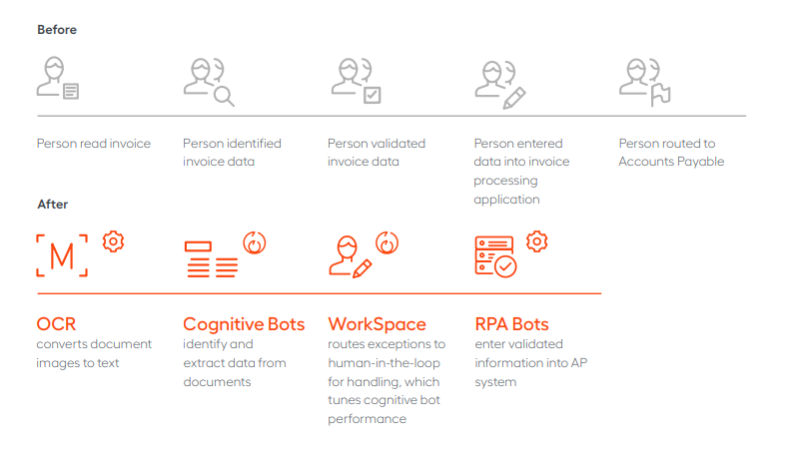

## **Proposed Solution**

An RPA solution that automates the entire invoice validation process, from downloading an invoice copy to capturing, validating and updating invoice details in the client’s web application and generating a unique identification number to ensure timely payment processing.

**Benefits**

#### **Time Savings**

Accounts payable automation makes invoice processing and approval exponentially faster.

#### **Streamlined, Accurate Processing**

Automated matching processes 80 percent of invoices straight through from capture to payment.

#### **Easy Access, Real-Time Monitoring, and Greater Control.**

#### **Better Insight and Transparency**

Greater visibility into the Accounts Payable process gives accountants and business leader’s keen insight.

## **References**

* [**http://greysoft.co/blog/index.php/case-studies/robotic-process-automation-invoice-processing/**](http://greysoft.co/blog/index.php/case-studies/robotic-process-automation-invoice-processing/)
* [**https://thelabconsulting.com/robotic-accounting-5-use-cases-case-study-examples-rpa-finance-accounting-departments/**](https://thelabconsulting.com/robotic-accounting-5-use-cases-case-study-examples-rpa-finance-accounting-departments/)
* [**https://youtu.be/gp3hG9UFFk4**](https://youtu.be/gp3hG9UFFk4)
* [**https://www.cognizant.com/case-studies/accounts-payable-invoice-automation**](https://www.cognizant.com/case-studies/accounts-payable-invoice-automation)